**NAME : SHRAVYA**

**DATE : 02-03-2023**

**TASK-2**

**1)Perform IP address spoofing:**

IP address spoofing or IP spoofing is the creation of Internet Protocol packets with a false source IP address, for the purpose of impersonating another computing system.

**Command:**

$ ifconfig

$ sudo ifconfig eth0 192.168.233.126

$ ifconfig

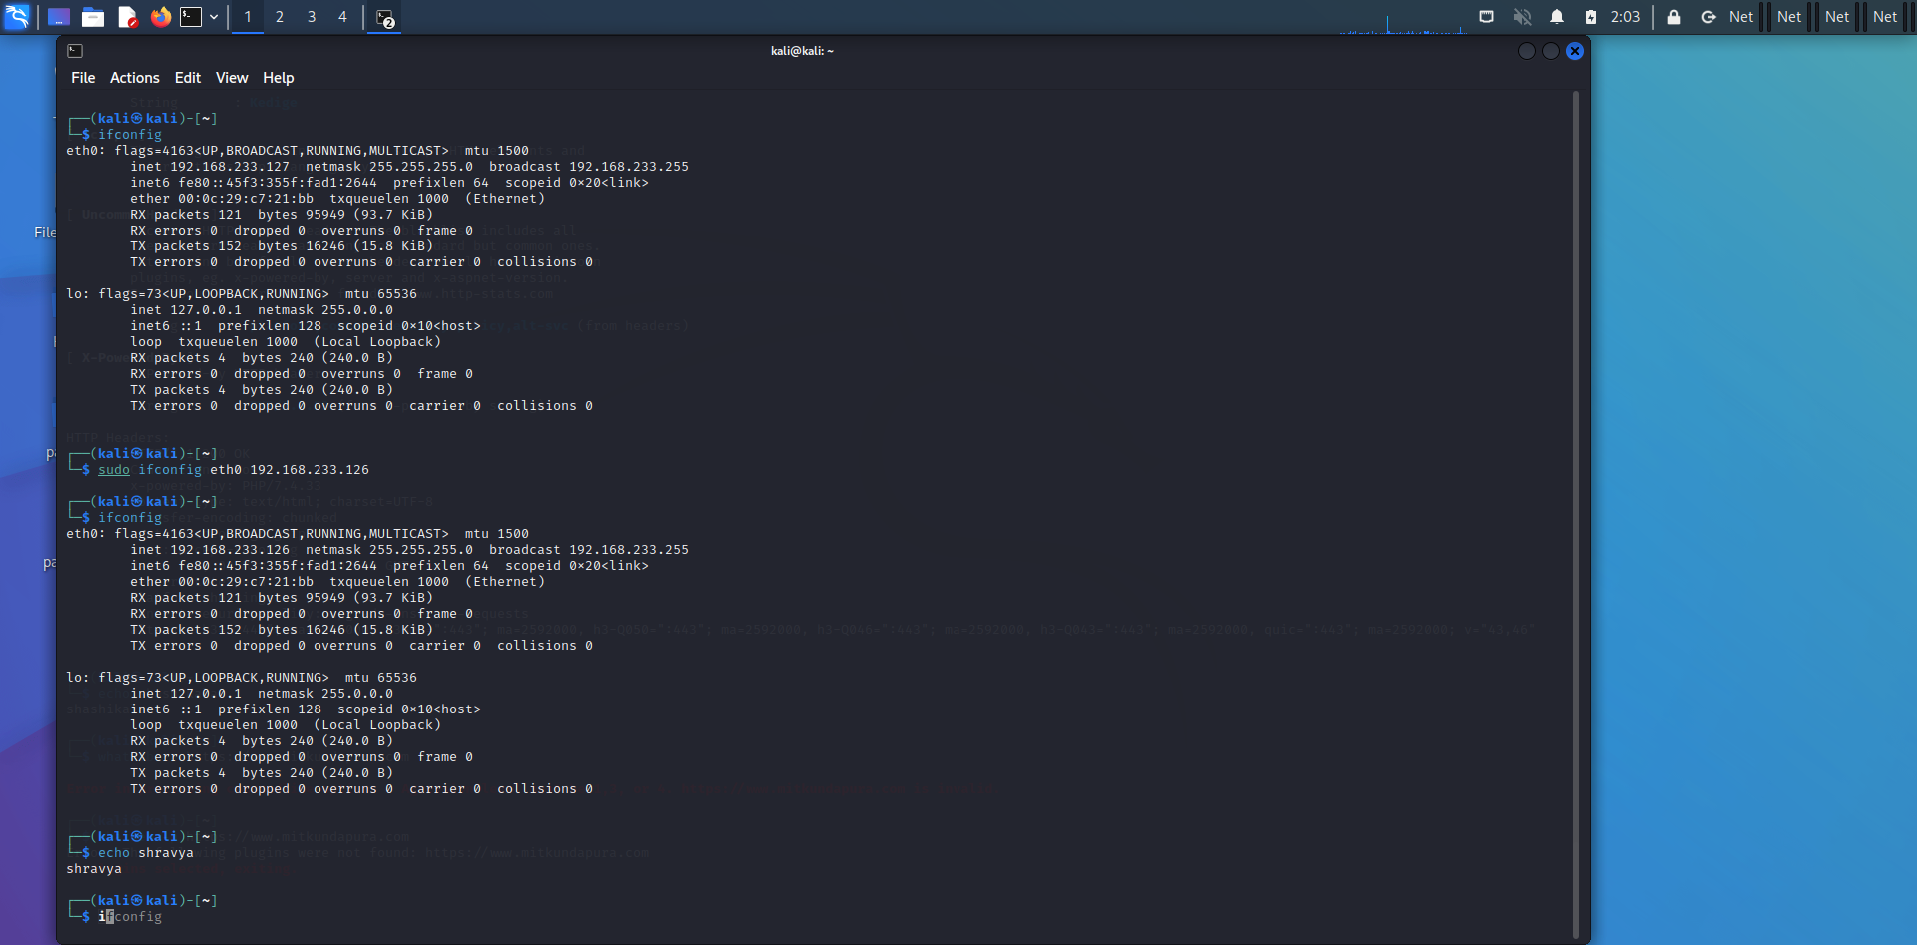

**2)Perform Mac address spoofing:**

A MAC spoofing attack is when a hacker changes the MACaddress of their device to match the MAC address of another on a network in order to gain unauthorized access orlauncha Man-in-the-Middle attack.

**Command:**

$ macchanger -s eth0

$ sudo macchanger -r eth0

$ ifconfig

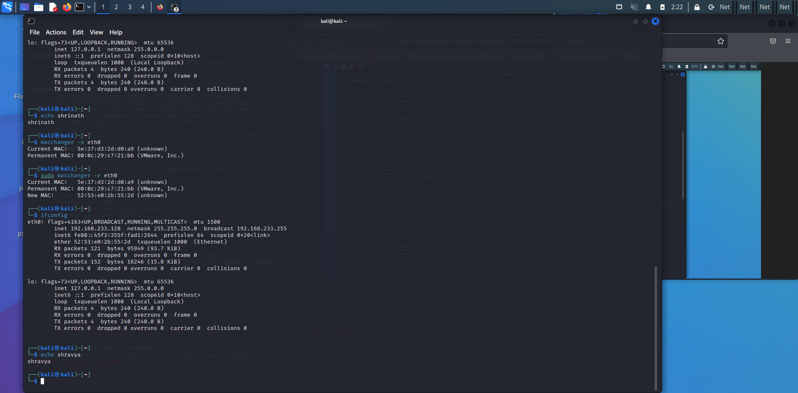

**3)Any 5 Whatweb commands:**

WhatWeb identifies websites. It recognises web technologies including content management systems (CMS), blogging platforms, statistic/analytics packages, JavaScript libraries, web servers, and embedded devices. WhatWeb has over 900 plugins, each to recognise something different. It also identifies version numbers, email addresses, account IDs, web framework modules, SQL errors, and more.

**Command:**

$ whatweb <https://www.mitkundapura.com>

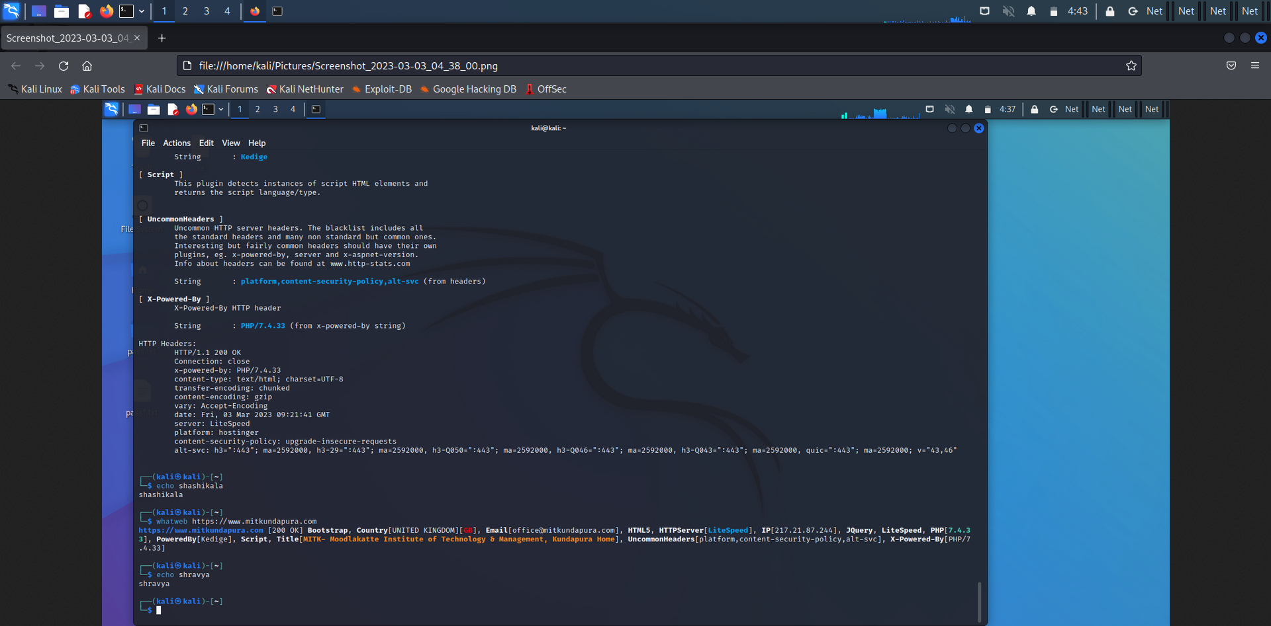

$ whatweb -v <https://www.mitkundapura.com>

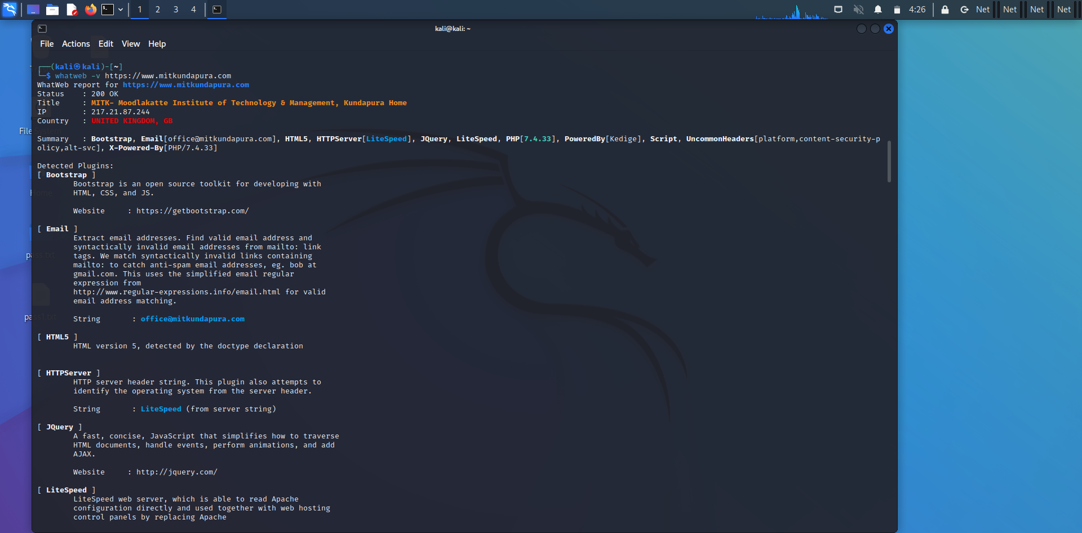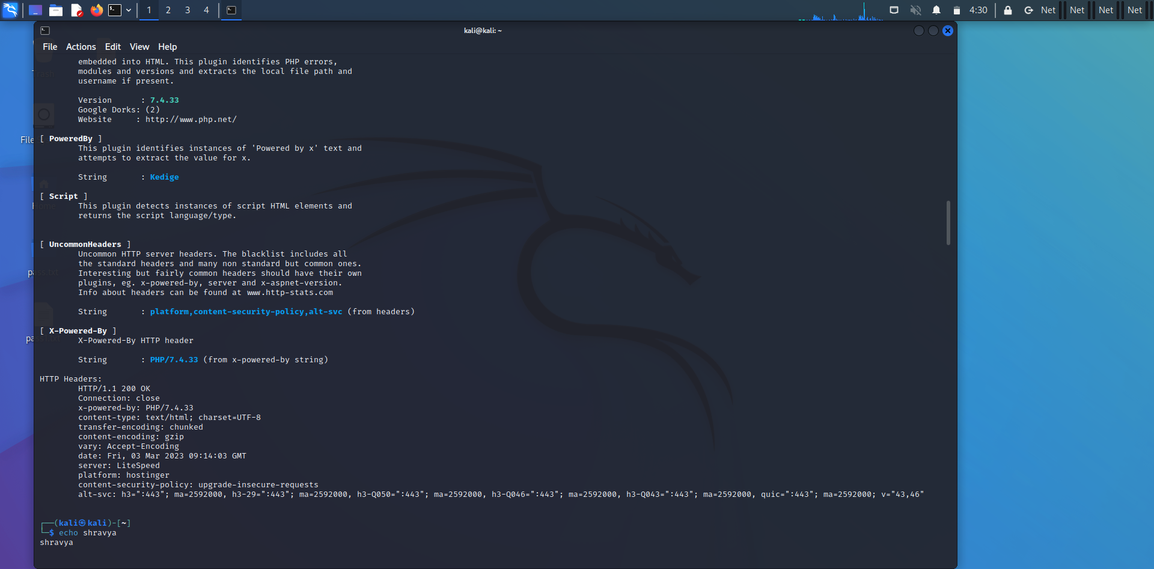

$ whatweb -a 3 <https://www.mitkundapura.com>

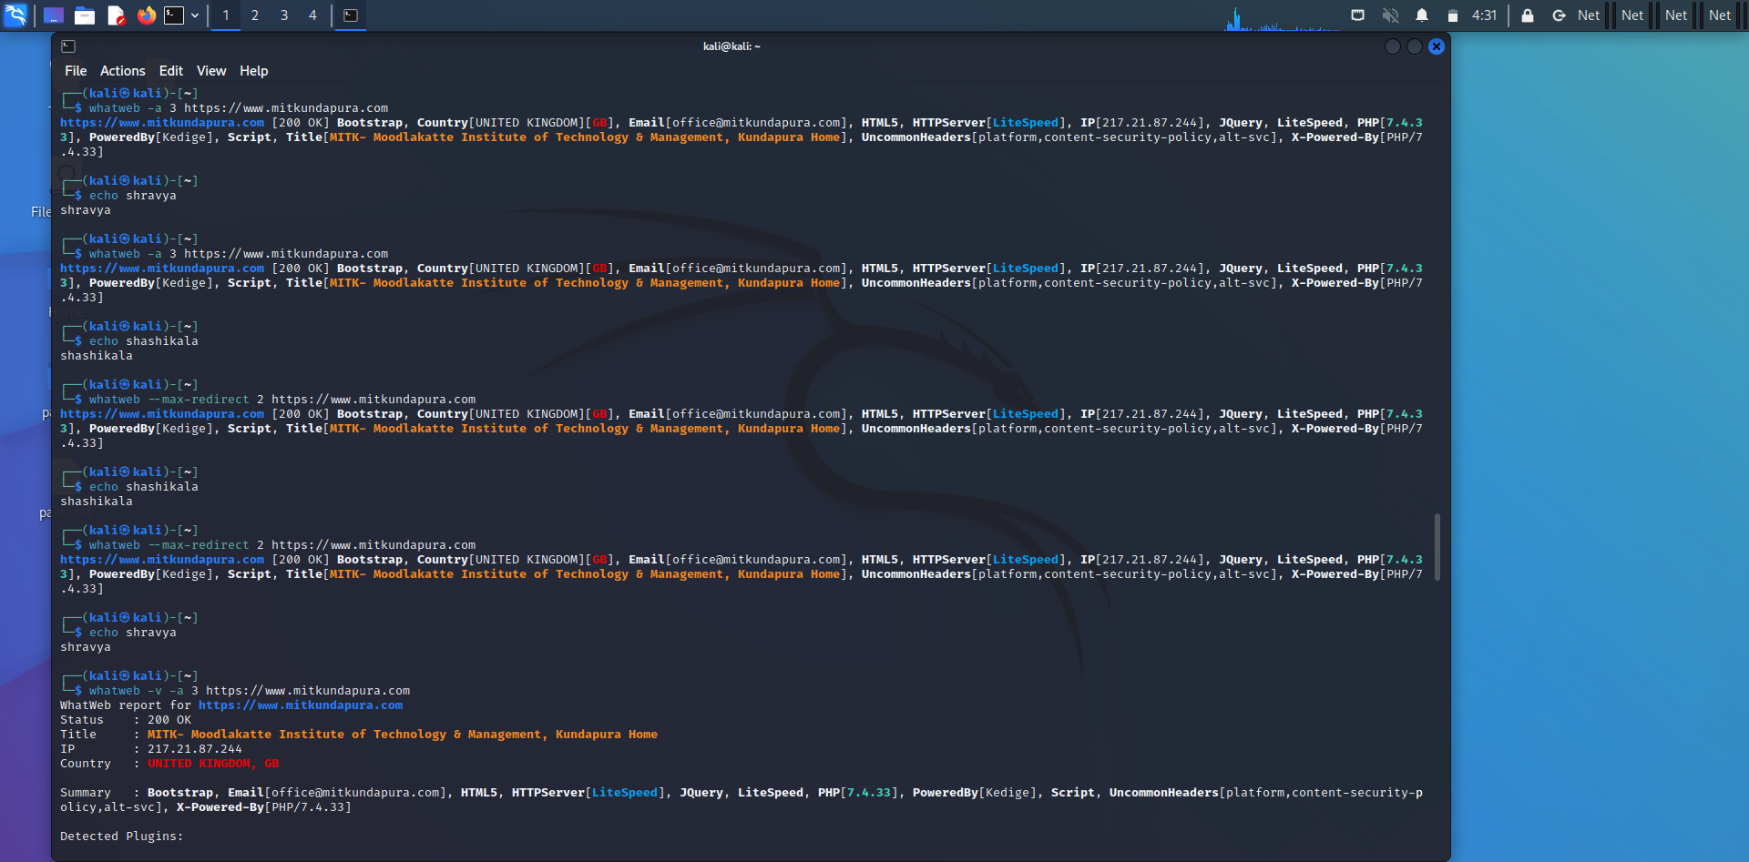

$ whatweb –max-redirect 2 <https://www.mitkundapura.com>



$ whatweb -a -v 3 <https://www.mitkundapura.com>

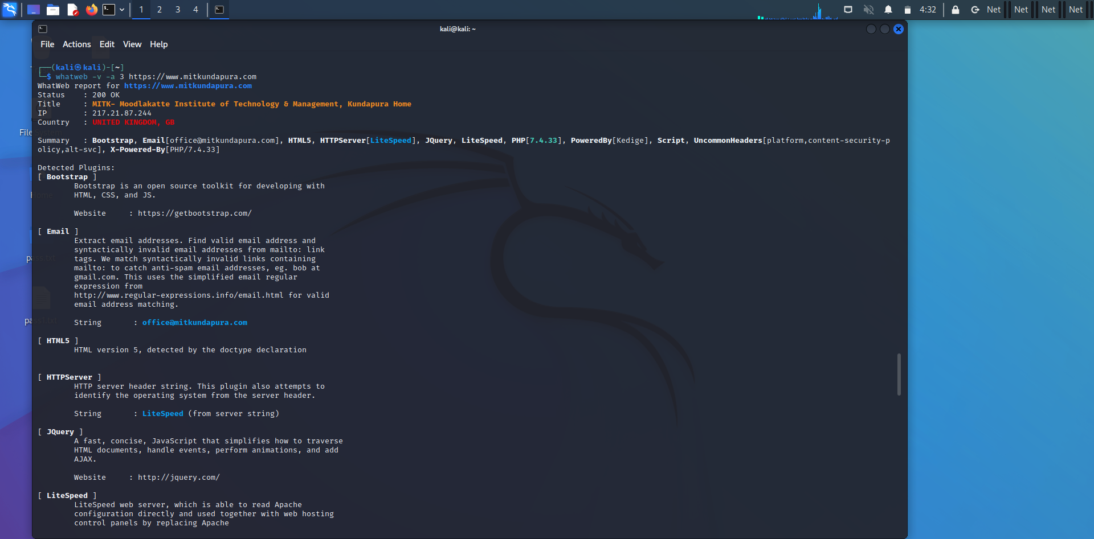

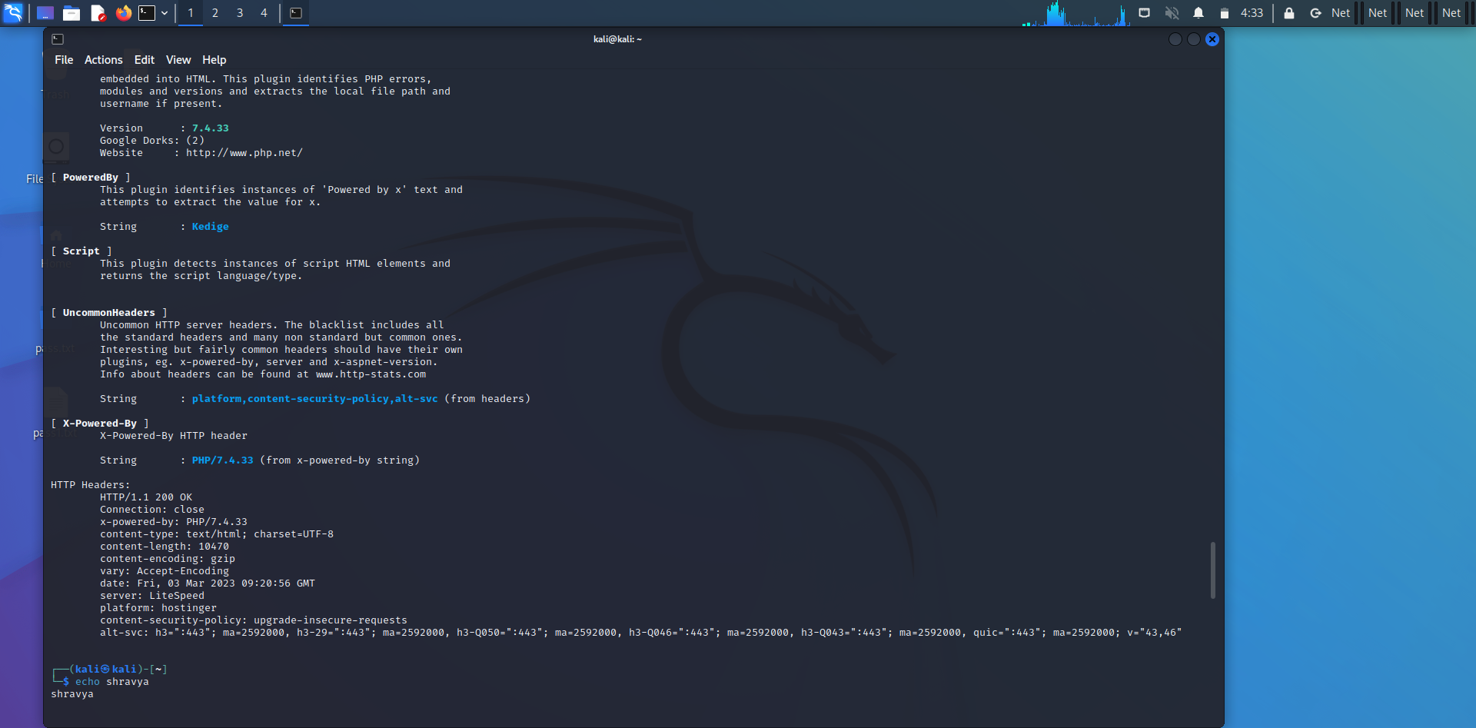

**4)Any 5 Nslookup commands:**

Nslookup is a network administration command-line tool for querying the Domain Name System to obtain the mapping between domain name and IP address, or other DNS records

**Command:**

$ nslookup -type=aaaa mitkundapura.com

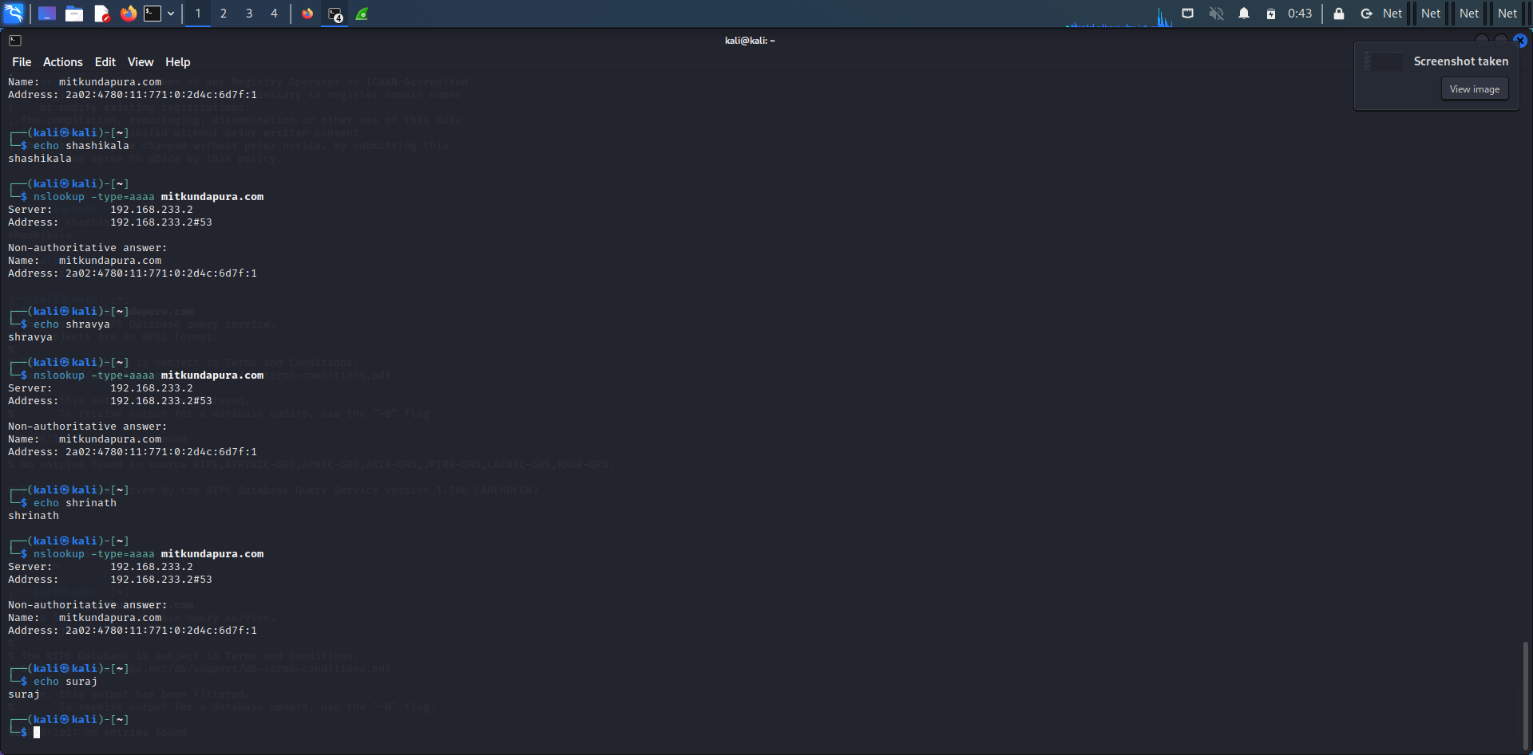

$ nslookup -type=a mitkundapura.com

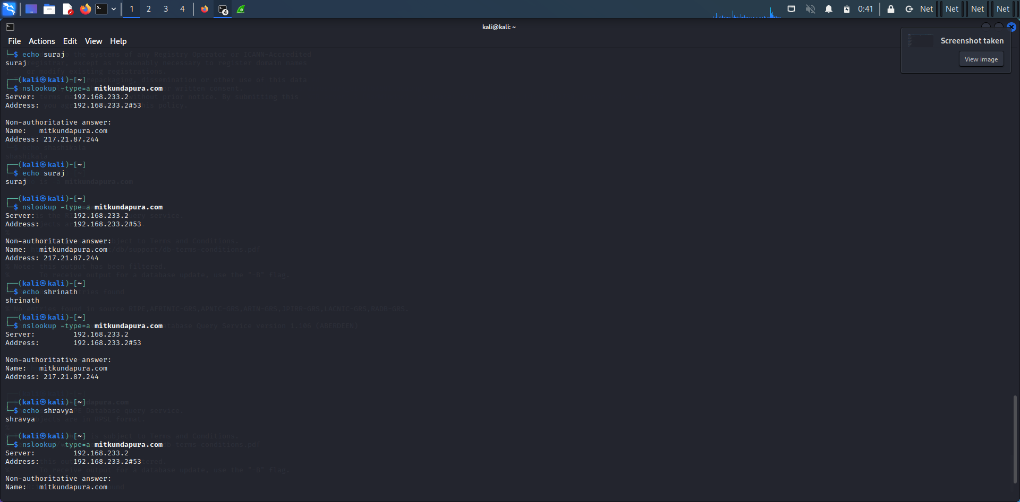

$ nslookup -type=ns mitkundapura.com

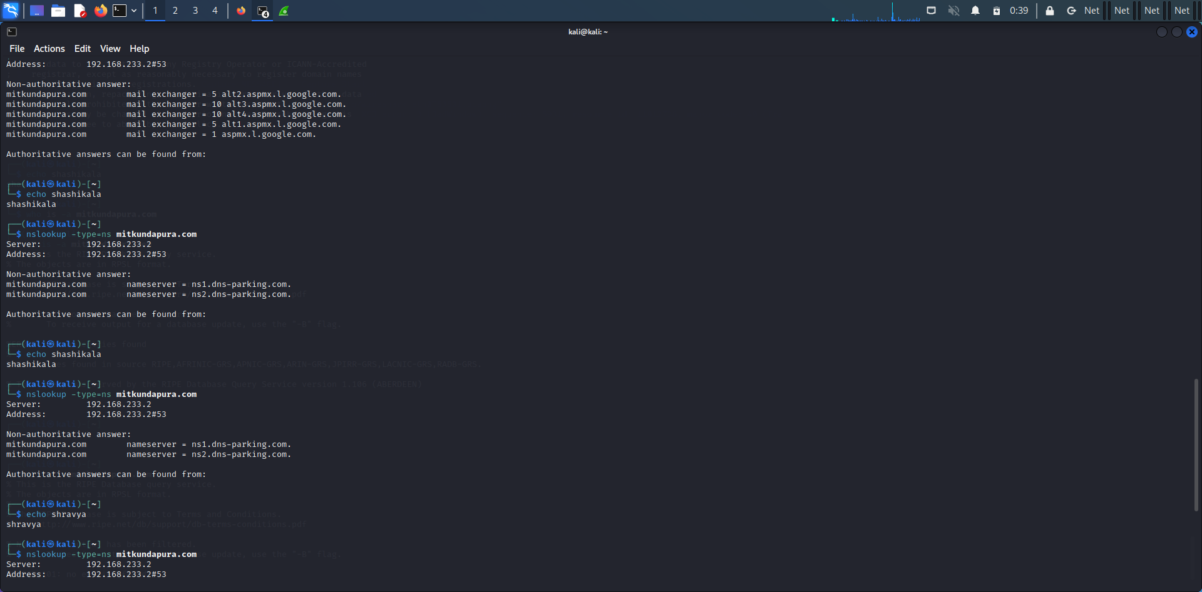

$ nslookup -type=mx mitkundapura.com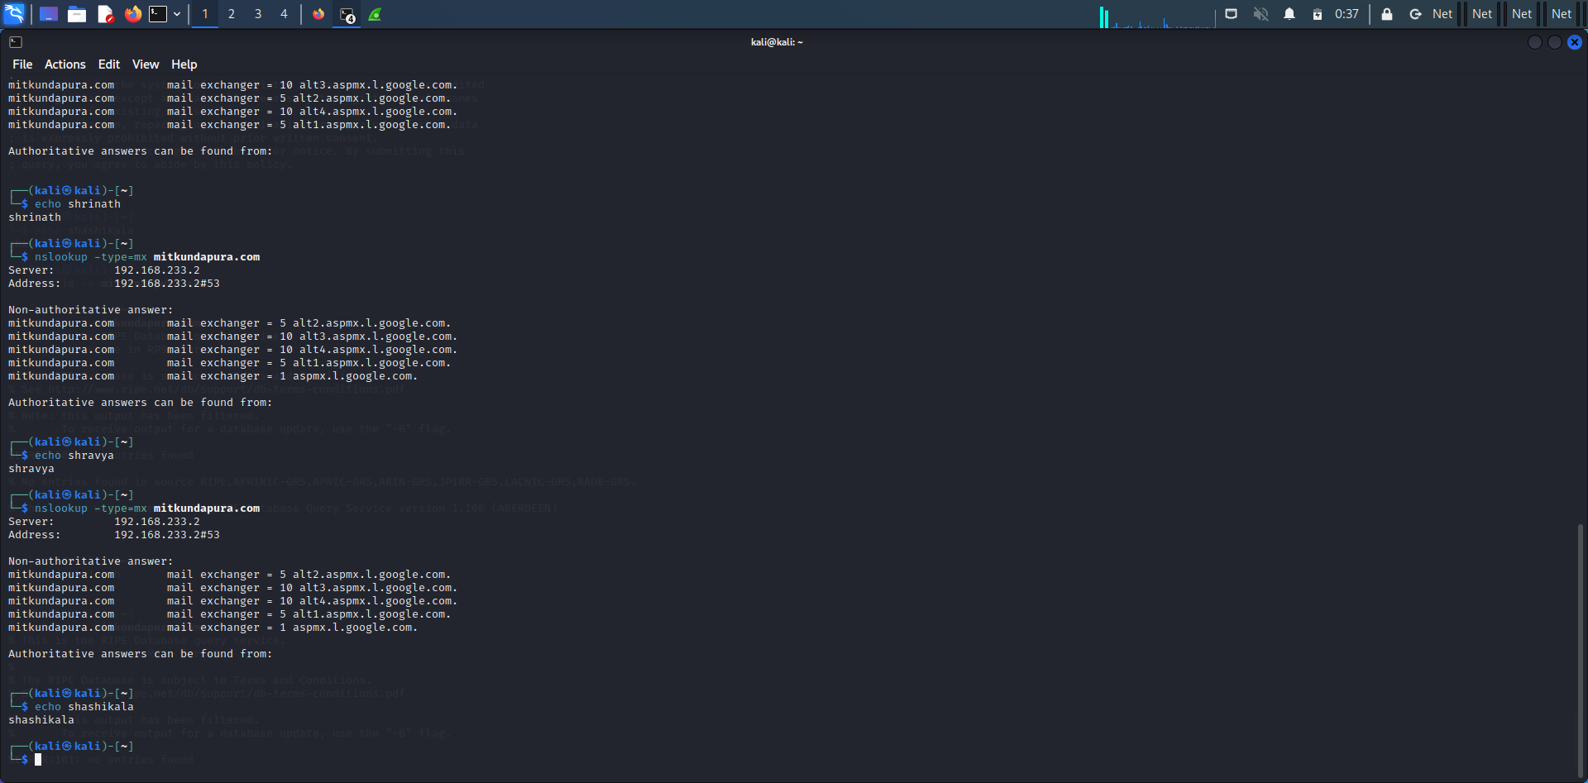

$ nslookup google.com

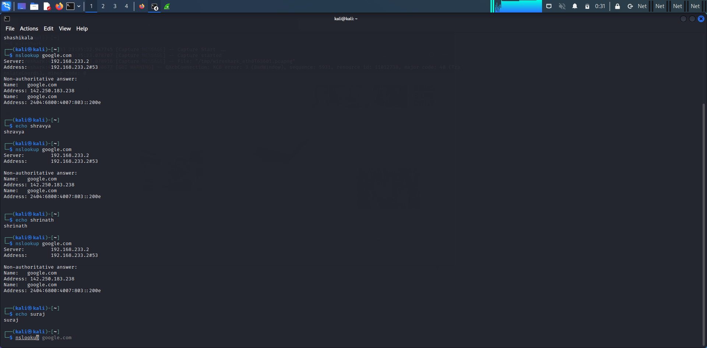

**5)Whois command:**

WHOIS is a query and response protocol that is widely used for querying databases that store the registered users or assignees of an Internet resource, such as a domain name, an IP address block or an autonomous system, but is also used for a wider range of other information.

**Command:**

$ whois mitkundapura.com

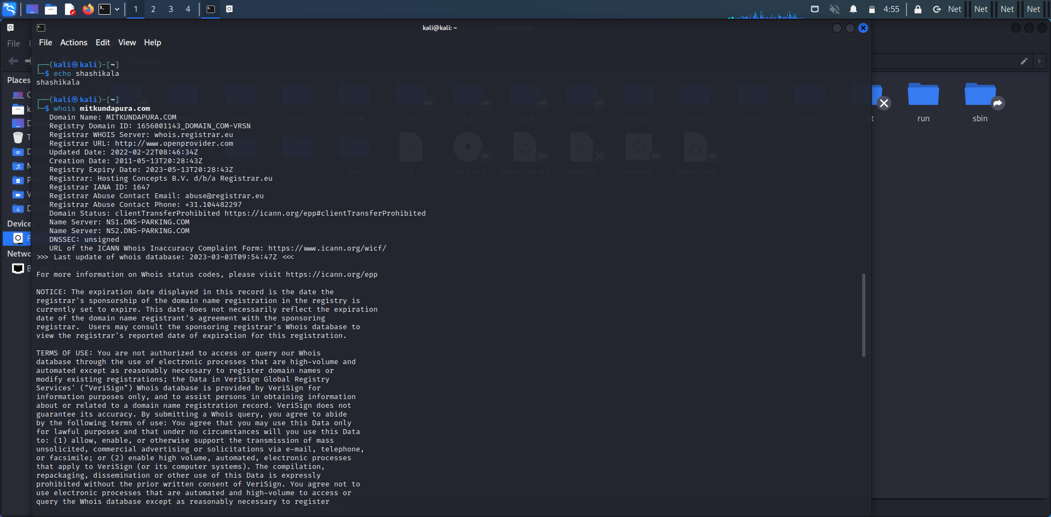

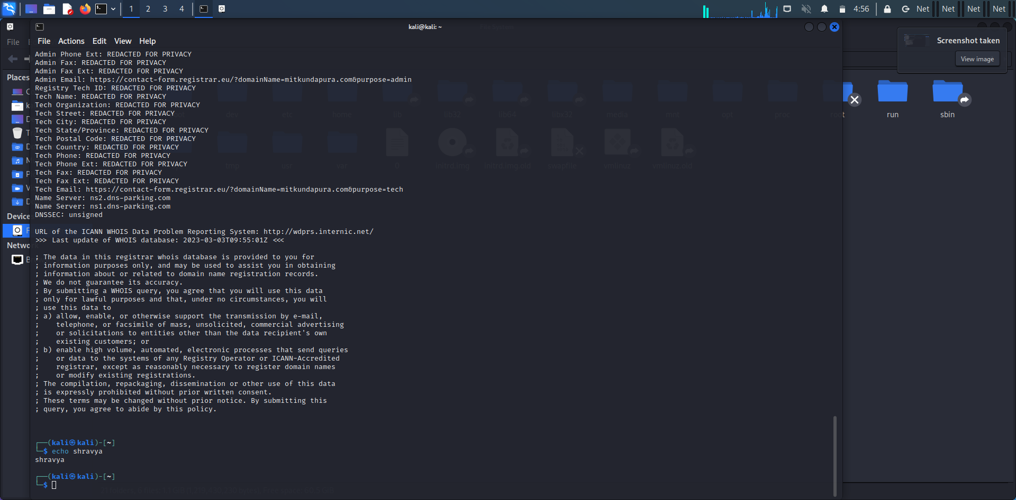

**6)Find data packet using wireshark:**

Wireshark is a network protocol analyzer, or an application that captures packets from a network connection, such as from your computer to your home office or the internet. Packet is the name given to a discrete unit of data in a typical Ethernet network. Wireshark is the most often-used packet sniffer in the world.

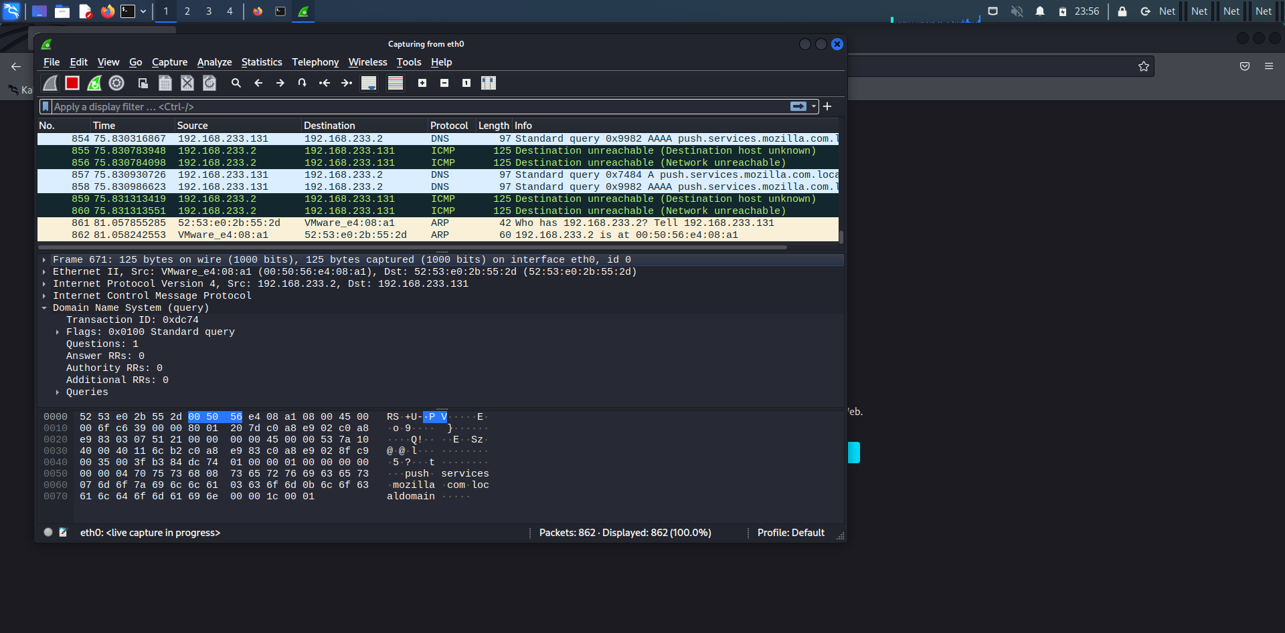

**7)Any 5 Netdiscover commands:**

The netdiscover is a tool which is used to gather all the important information about the network. It gathers information about the connected clients and the router.

**Command:**

$ netdiscover –I eth0

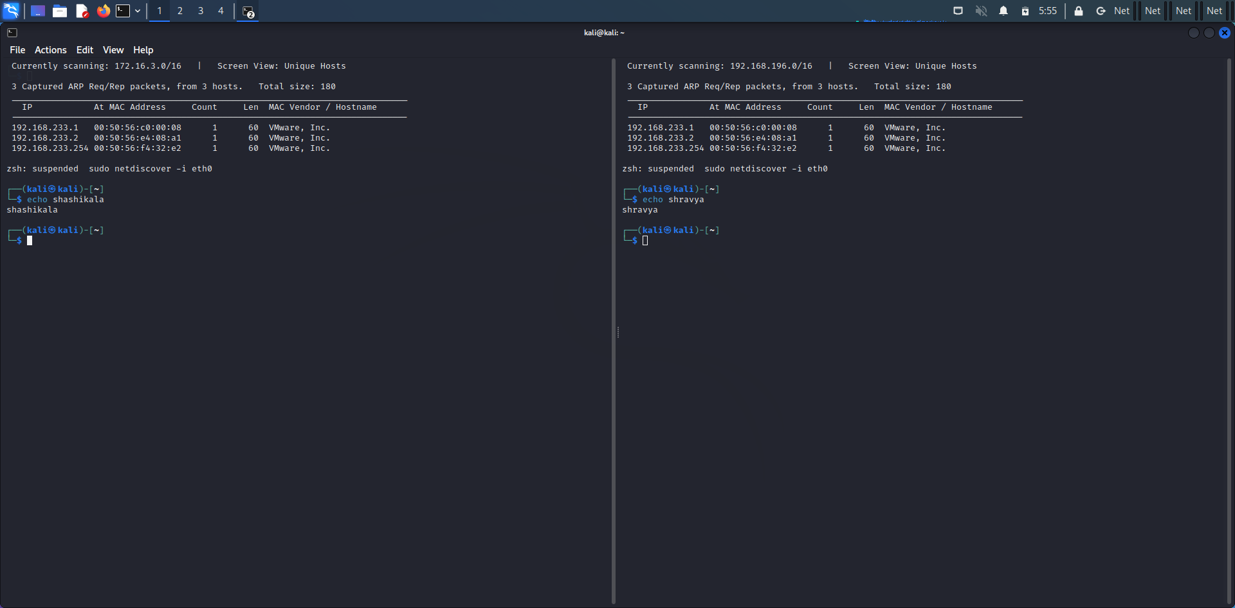

$ sudo netdiscover -i eth0 -f

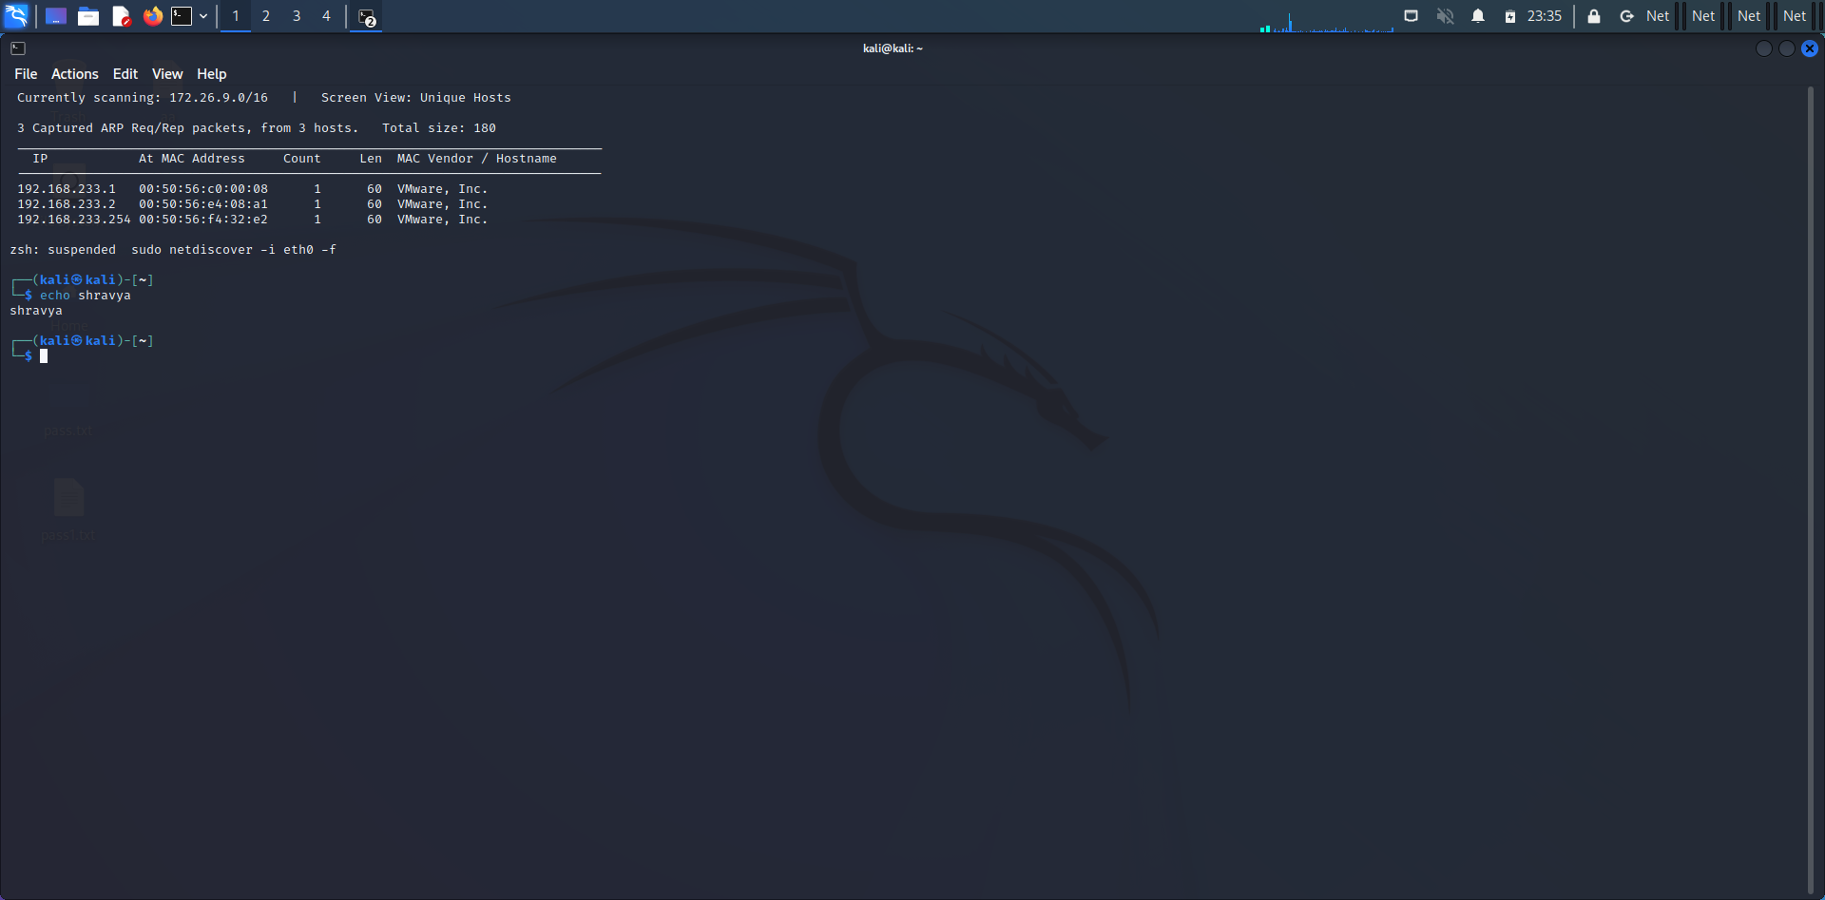

$ netdiscover -p

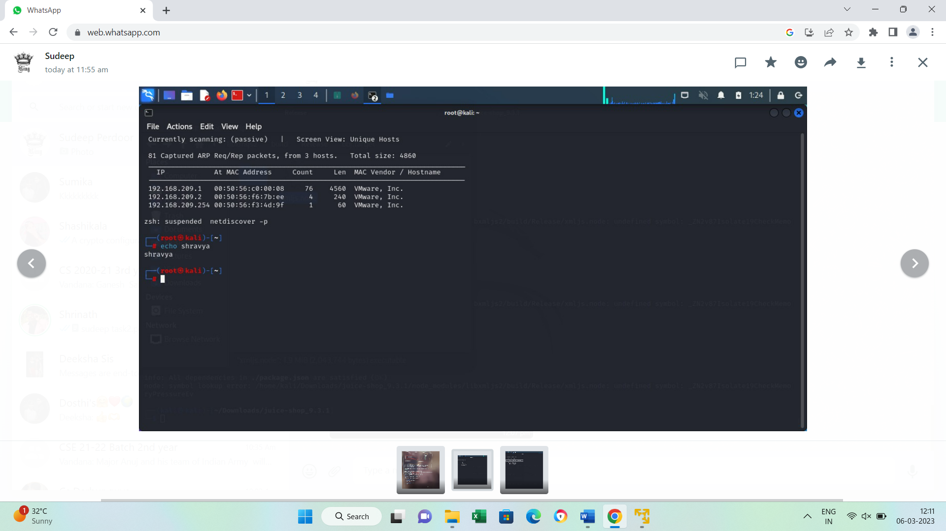

$ sudo netdiscover –s 0.5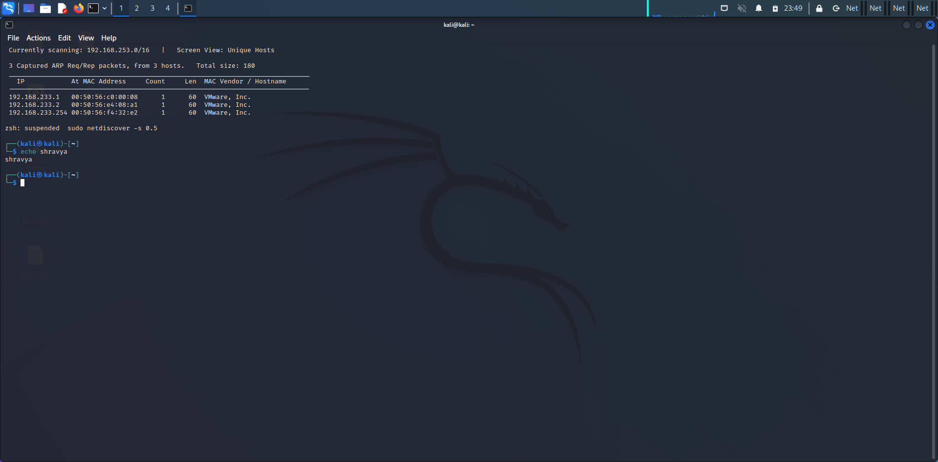

$ netdiscover –r 192.168.0.15

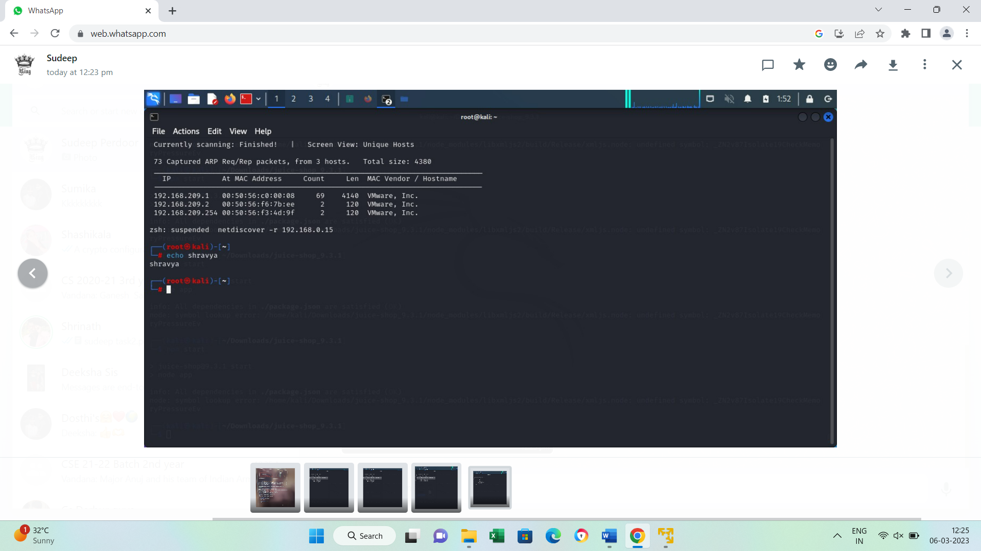

**8)CryptoConfiguration Flaw:**

A crypto configuration flaw refers to a security vulnerability that occurs due to improper configuration of cryptographic settings in a system or application. Cryptography is the science of using mathematical algorithms to protect data from unauthorized access or modification, and it is an essential component of modern computer security.

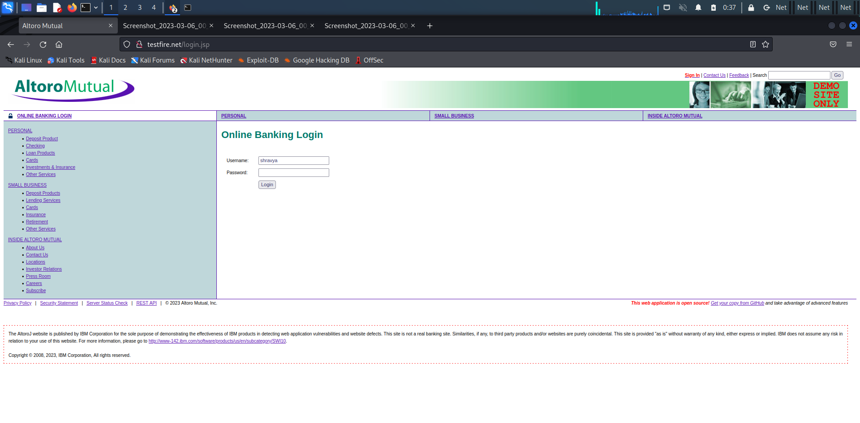

**9)Nikto commands:**

Nikto is a free software command-line vulnerability scanner that scans webservers for dangerous files/CGIs, outdated server software and other problems. It performs generic and server type specific checks. It also captures and prints any cookies received.

**Command:**

$ nikto –host facebook.com

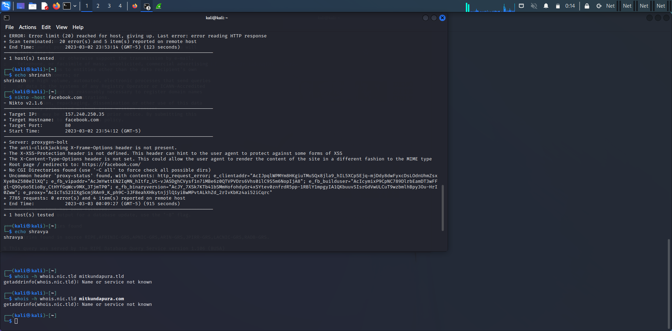

**10)Find Xml pages in website using dirbuster:**

DirBuster is a multi threaded java application designed to brute force directories and files names on web/application servers. Often is the case now of what looks like a web server in a state of default installation is actually not, and has pages and applications hidden within.

